Home Health Supervisory Visit

In order to complete the home health supervisory visit to meet the new CoP regulations – the clinician MUST check “YES’ under Comprehensive Evaluation

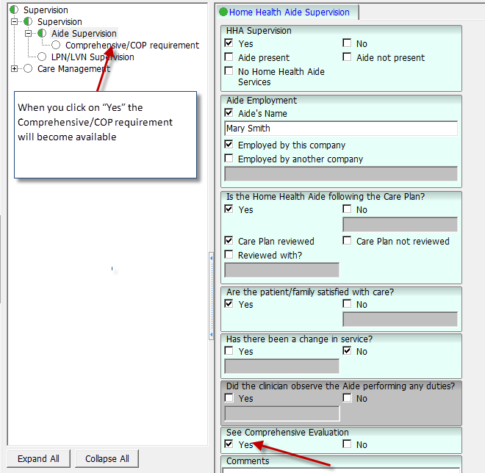

When you click on “Yes” the Comprehensive/CoP requirement will become available
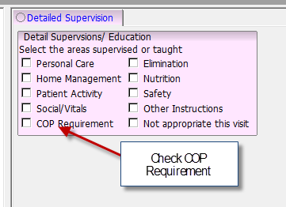

When you check COP requirement a pop-up tab will appear called COP requirement and complete each section to meet the new CoP requirement.

